**Atyre Arvox-Qualt** 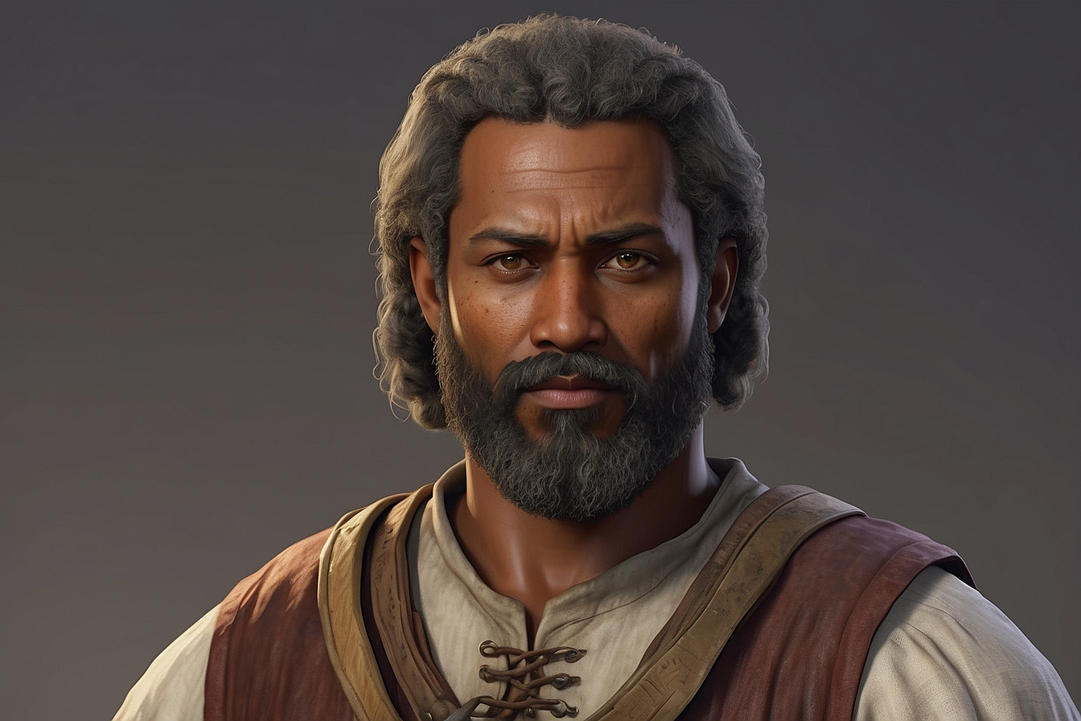

**Farmer**

**Ard Ipholar**



Retiree

**Anhlaw Twanalor**

Alchemist

**Albaize Xorandor**

Thief